1. Head to Settings > Privacy & security > For developers  
   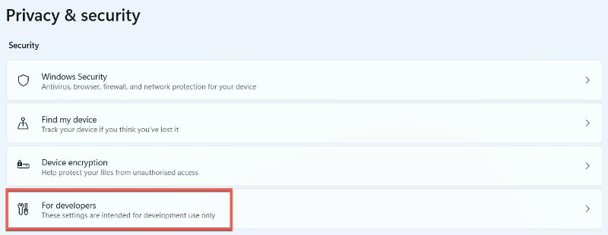
2. Under ‘Developer Mode’, click the toggle to turn it on, then click ‘Yes’ to confirm  
   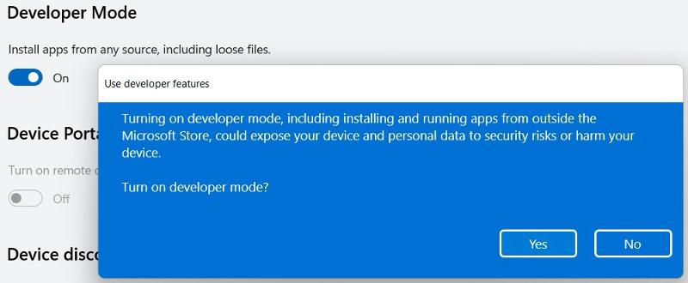
3. Download the following 859Mb file on x64 devices: [WSA-GApps-pico_2204.40000.20.0_x64_Release-Nightly.zip](https://go.redirectingat.com/?id=803X112721&url=https://mega.nz/file/tsgVVC5Q#jz70W6MKh3itXkHsPowtprch17CgzrKxKXynJnUagCI&xcust=4-1-745060-1-0-0&sref=https://www.techadvisor.com/article/745060/how-to-get-the-google-play-store-on-windows-11.html). On ARM-based devices, use this link instead: [WSA-GApps-pico_2204.40000.20.0_arm64_Release-Nightly](https://go.redirectingat.com/?id=803X112721&url=https://mega.nz/file/99JW0YLK#1Dix2juIzkUPX-sVXGUvH1wZbwPasNkCWpo5eGZpdv8&xcust=4-1-745060-1-0-0&sref=https://www.techadvisor.com/article/745060/how-to-get-the-google-play-store-on-windows-11.html)
4. Once complete, head to the Downloads folder within File Explorer and locate the file. Select it and choose ‘Extract all’ – this will take a few seconds

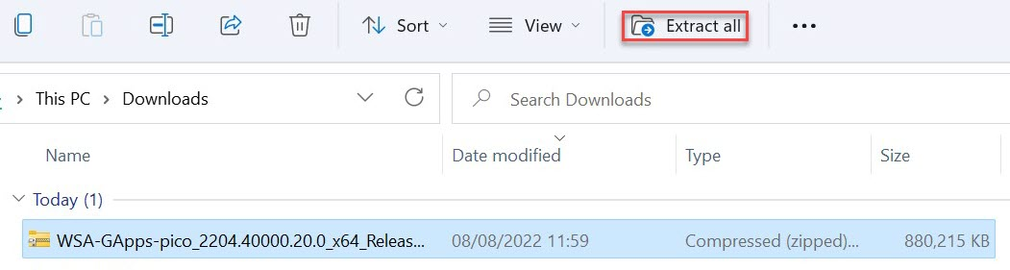

Anyron Copeman / Foundry

1. Select the extracted file and hit Ctrl + C to copy
2. Open the C: drive from the left pane, then hit Ctrl + V to paste it. The folder should appear below ‘Windows’ in the list
3. From the pop-up that appears, click ‘Continue’ to provide administrator permission
4. Select the search bar next to the Start menu and type ‘powershell’. From the options that appear on the right, choose ‘Run as Administrator’ and click ‘Yes’ to confirm you allow changes to be made

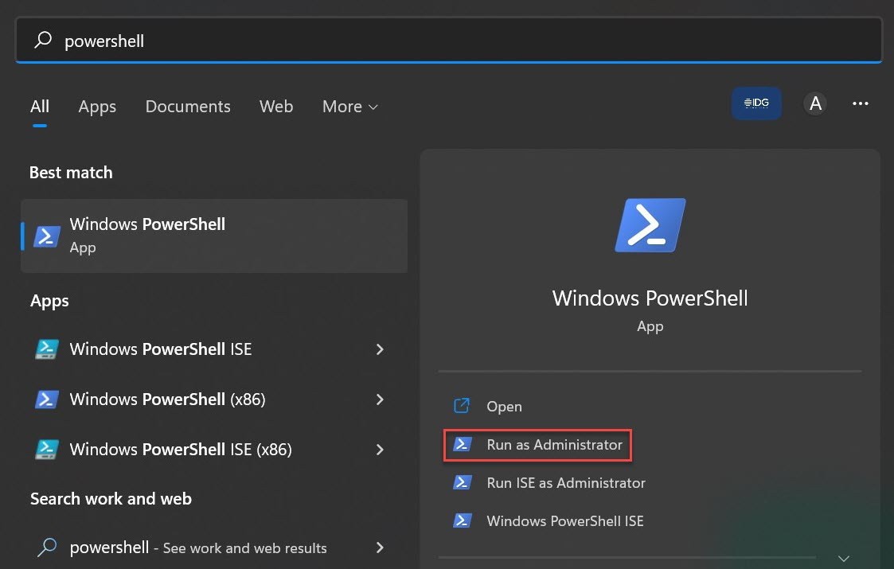

Anyron Copeman / Foundry

1. From the window that appears, click next to where it says ‘PS C:\WINDOWS\system32>’ and paste the following: **cd C:\WSA-GApps-pico_2204.40000.20.0_x64_Release-Nightly**
2. Hit enter, then paste the following: **Set-ExecutionPolicy -Scope Process -ExecutionPolicy Bypass**
3. Hit enter again, then type ‘A’ and hit enter once more
4. Then, copy the following and hit enter – **.\Install.ps1**

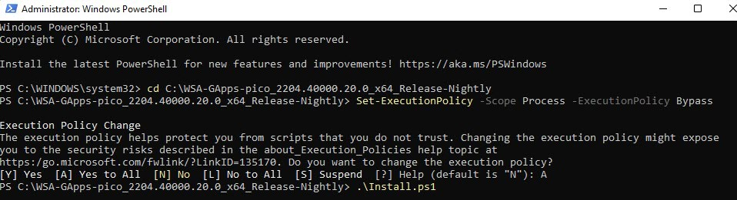

Anyron Copeman / Foundry

1. After a few seconds, you should see a message saying ‘The operation completed successfully’. Once processed, the Windows Subsystem for Android will begin running and the Play Store will automatically open

However, you may have seen a message saying ‘VirtWifi has no internet access’. The Play Store won’t run without it, but Windows Defender Firewall blocks it. It’s not safe to turn off the firewall completely, but you can make this the exception to the rule:

1. Using the search function next to the Start menu, type ‘advanced security’ and open ‘Windows Defender Firewall with Advanced Security’
2. From the bottom of the Overview section, click ‘Windows Defender Firewall Properties’

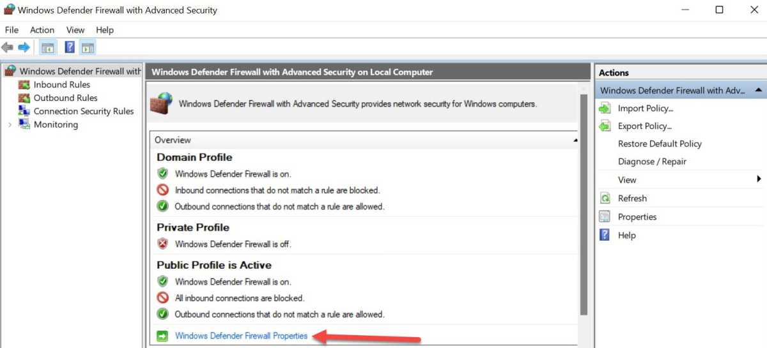

Anyron Copeman / Foundry

1. Next to ‘Protected network connections’, click ‘Customize…’

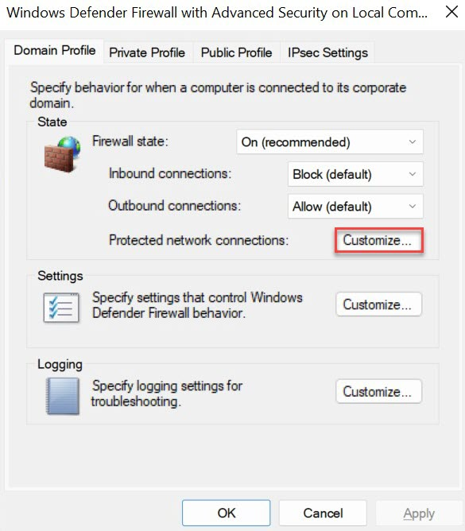

Anyron Copeman / Foundry

1. Uncheck the box next to ‘vEthernet (WSL)’ and click ‘OK’

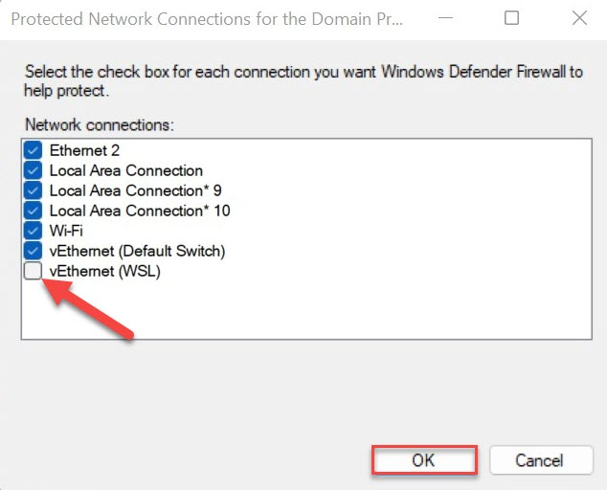

Anyron Copeman / Foundry

1. Click ‘OK’ again to confirm